Program Syllabus  
MGT-501 Certified 4IR Innovation Leader & Architect

## **Combining Design Thinking, Lean Startup and Agile to Drive Digital Innovation**

# 

# Teaching Team: Zia Khan & Adil Altaf

All PIAIC Karachi Batch 1 and 2 will take this class. As Zia Khan and Adil Altaf will be teaching this class, there will be no fee for this class.

The top 15% of Karachi (85% percentile and above) Batch 1 and 2 will be taking the onsite class:

Bahria Auditorium: Sundays - 05:45 PM to 09:45 PM  
 Location: <https://goo.gl/maps/kqt32tgngYd1sV9E7>

All remaining students will take the class online using the PIAIC portal.

# Summary

1. Subject(s): Design Thinking, Lean Startup, Agile
2. Topic or Unit of Study: Digital Innovation
3. Grade/Level: All PIAIC Students
4. Duration: 3 months

**Classes Starting from November 24th**

# Course Description

This program is designed for innovation leaders, startup founders, software developers, software project managers, entrepreneurs, intrapreneurs, and freelancers working on new, disruptive products and services within a larger enterprise or a small startup in the era of the fourth industrial revolution.

In this program, students will learn that innovation demands a combination of iterative, experimental approaches (Source: Gartner)

* Use Design Thinking to Understand the Customer and Discover the Real Need
* Evolve the Innovation Using Lean Startup
* Use Agile to Build Out and Evolve the Technology Elements of the Innovation

By combining design thinking, lean startup, and agile, you are far more likely to not only come up with better ideas but to turn those ideas into viable money makers and deliver them in a way that creates immediate value for customers, save your company from cost and schedule blowouts - synonymous with innovation at large companies - and give your employees the opportunity to partake in more rewarding and fulfilling work.

# 

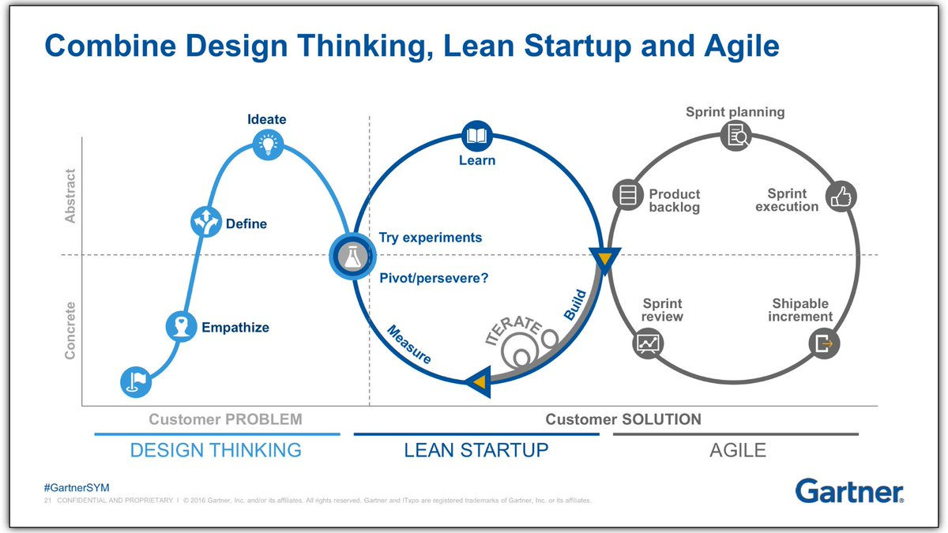

# Three International Certifications

1. PMI Agile Certified Practitioner (PMI-ACP)  
   <https://www.pmi.org/certifications/types/agile-acp>
2. Ideo U Foundations in Design Thinking Certificate  
   <https://www.ideou.com/pages/design-thinking-certificate>
3. Advanced Design Thinking Certificate  
   <https://www.ideou.com/pages/advanced-design-thinking>

# 

# Course Outline

|  |  |
| --- | --- |
| **Week** | **Agenda** |
| 1 | **Introduction** to combine Design Thinking, Lean Startup, and Agile to Drive Innovation by Gartner Research |
| 2 | **Agile Project Management**  *PMI-ACP Exam Prep, Updated Second Edition* by Mike Griffiths |
| 3 |
| 4 |
| 5 |
| Quiz | **Quiz 1 - Agile** |
| 6 | **Lean Startup**  *The Lean Startup* by Eric Ries |
| 7 |
| 8 |
| Quiz | **Quiz 2 - Lean Startup** |
| 9 | **Design Thinking**  *The Design Thinking Playbook* by Michael Lewrick |
| 10 |
| 11 |
| 12 |
| Quiz | **Quiz 3 - Design Thinking** |
| 13 | **Integrating Design Thinking, Lean Startup, and Agile**  *Enterprise Architects Combine Design Thinking, Lean Startup, and Agile to Drive Digital Innovation* by Gartner Research |
| Final Exam | **Final Exam - Digital Innovation by Combining Design Thinking, Lean Startup, and Agile** |

# 

# Materials & Resources

We will use the following text books and research papers for this program:

1. [Enterprise Architects Combine Design Thinking, Lean Startup and Agile to Drive Digital Innovation by Gartner Research](https://www.gartner.com/en/documents/3941917/enterprise-architects-combine-design-thinking-lean-start)
2. [PMI-ACP Exam Prep, Updated Second Edition: A Course in a Book for Passing the PMI Agile Certified Practitioner (PMI-ACP) Exam by Mike Griffiths](https://www.amazon.com/PMI-ACP-Exam-Prep-Updated-Second/dp/1932735984/ref=sr_1_1)
3. [The Lean Startup: How Today's Entrepreneurs Use Continuous Innovation to Create Radically Successful Businesses by Eric Ries](https://www.amazon.com/Lean-Startup-Entrepreneurs-Continuous-Innovation/dp/B005MM7HY8/ref=sr_1_1)
4. [The Design Thinking Playbook: Mindful Digital Transformation of Teams, Products, Services, Businesses and Ecosystems by Michael Lewrick, Patrick Link, and Larry Leifer](https://www.amazon.com/Design-Thinking-Playbook-Transformation-Businesses/dp/1119467470/ref=sr_1_1)

# Assessment

Students will be graded based on Percentile  
<https://en.wikipedia.org/wiki/Percentile>  
<https://en.wikipedia.org/wiki/Percentile_rank>

|  |  |
| --- | --- |
| **Grade** | **Percentile Range** |
| A | 78 - 99 |
| B | 41 - 77 |
| C | 23 - 40 |
| D | 1 - 22 |
| F | 0 (Missed 2 or more exams) |

**Note:** Any student who receives a F-Grade will be removed from the program. Students who receive a D-Grade will be put on probation, and be required to earn a grade of C or above in the next quarter, to remain in the program. Anyone absent from an exam will be deemed to have received a score of zero.